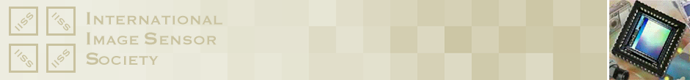

**INTERNATIONAL IMAGE SENSOR SOCIETY (IISS)**

**EXCEPTIONAL LIFE-TIME ACHIEVEMENT   
AWARD NOMINATION FORM**

1. Nominator Information

|  |  |
| --- | --- |
| Prefix |  |
| First Name |  |
| Last Name |  |
| Affiliation |  |
| E-mail Address |  |
| Nomination Date |  |

2. Nominee Information

|  |  |
| --- | --- |
| Prefix |  |
| First Name |  |
| Last Name |  |
| Affiliation |  |
| E-mail Address |  |

3. Suggested Citation: “For Contributions to ______________________

*Please go on to the next page.*

4. Explain how the nominee’s sustained and exceptional contributions to the field of solid-state image sensors, over the course of his/her career, have impacted the industry. Explain how the nominee’s contributions have had a lasting impact on society. Identify why the nominee ranks near the top of those in his/her discipline.

5. List the accomplishments that support the nominee’s recommendation in the areas identified in question 4. These include technical publications; technical reports and presentations, patents, development of products, applications and systems, application of facilities and services and his/her resume.

6. Describe your relationship to the nominee and how you personally became aware of the importance of his/her extraordinary accomplishments and their impact on the image sensor community: (Optional, Max 100 words)