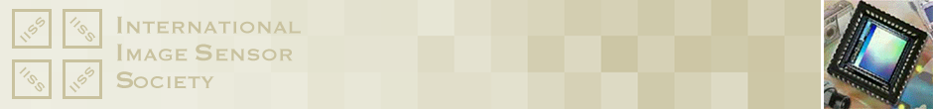

**INTERNATIONAL IMAGE SENSOR SOCIETY (IISS)**

**PIONEERING ACHIEVEMENT   
AWARD NOMINATION FORM**

1. Nominator Information

|  |  |
| --- | --- |
| Prefix |  |
| First Name |  |
| Last Name |  |
| Affiliation |  |
| E-mail Address |  |
| Nomination Date |  |

2. Nominee Information

|  |  |
| --- | --- |
| Prefix |  |
| First Name |  |
| Last Name |  |
| Affiliation |  |
| E-mail Address |  |

3. Suggested Citation: “For Contributions to ______________________

*Please go on to the next page.*

4. Explain how the nominee’s pioneering technical contributions have influenced the field of solid-state image sensors. Explain how the nominee’s contributions are pioneering and why they have had a lasting impact on society. Identify why the nominee ranks near the top of those in his/her discipline.

5. List the accomplishments that supports the nominee’s contributions in the area identified in question 4. These include technical publications, technical reports and presentations, patents, development of products, applications and systems, application of facilities and services and his/her resume.

6. Describe your relationship to the nominee and how you personally became aware of the importance of his/her extraordinary accomplishments and their impact on the image sensor community: (Optional, Max 100 words)